**Homework 5**

Richard L. McCormick

Northern Arizona University

STA471: Statistical Regression

Dr. Jin Wang

October 31st, 2023

# Show that (***I–H***) is a symmetric and idempotent matrix, where ***H = X(XTX)-1XT***.

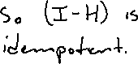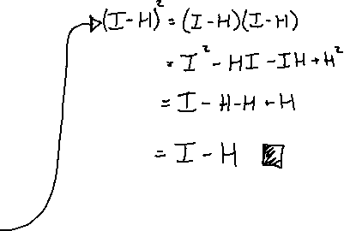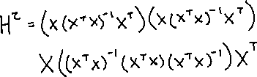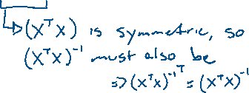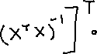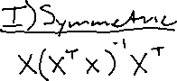

# Suppose that we are given the data below:

|  |  |  |  |  |
| --- | --- | --- | --- | --- |
| **X** | 1 | 3 | 6 | 4 |
| **Y** | 4.2 | 2.3 | 2.7 | 2.0 |

## Write out the matrix form of the linear regression model for the data.

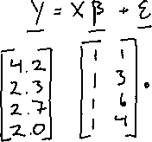

## Compute ***XTX***, ***XTY***, and ***YTY***.

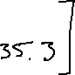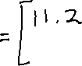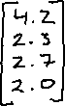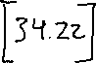

## Find ***(XTX)-1***.

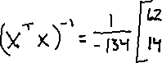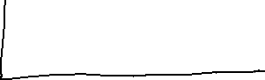

## Find ***H = X(XTX)-1XT***.

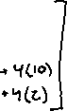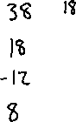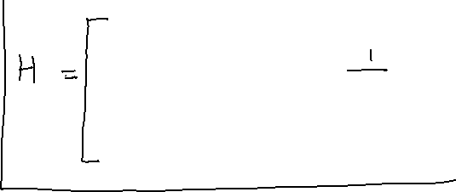

## Find ***b***.

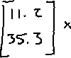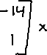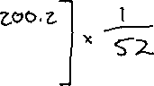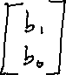

## Find ***Ŷ***.

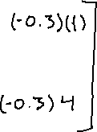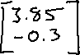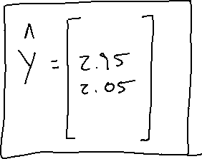

## Find ***e***.

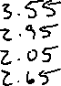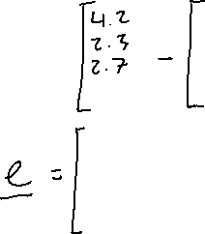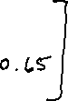

## Find ***s2 = MSresid***.

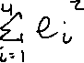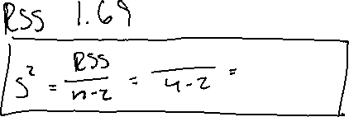

## Verify that ***Syy = Σ (Yi - Ȳ)2 = YT(In – 1/n 1 1T)Y*** using the sample information.

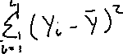

## Find R2 and rxy.

